Name:P.Gayathri
Reg.No:192424324

4.Write a Python program to solve a Crypt-Arithmetic problem by assigning unique digits

Aim:
To solve a Crypt-Arithmetic problem by assigning unique digits to letters so that the given arithmetic equation is satisfied.
Algorithm:
Step 1: Start.
Step 2: Read the three words (Operand1, Operand2, and Result).
Step 3: Extract all unique letters from the three words.
Step 4: Check whether the number of unique letters is greater than 10. If yes, print "No solution possible" and stop.
Step 5: Generate all possible permutations of digits (0–9) for the unique letters.
Step 6: Assign each digit to a unique letter.
Step 7: Ensure that the first letter of each word is not assigned the digit 0.
Step 8: Convert the words into their corresponding numeric values using the assigned digits.
Step 9: Check whether:
Operand1 + Operand2 = Result
Step 10: If the equation is satisfied, display the letter-to-digit mapping and the corresponding numbers, then stop.
Step 11: Otherwise, try the next digit assignment.
Step 12: If all assignments are checked and no solution is found, print "No solution found."
Step 13: Stop.

PROGRAM:

from itertools import permutations

def solve(a, b, c):
letters = list(set(a + b + c))
if len(letters) > 10:
return

first = {a[0], b[0], c[0]}

for perm in permutations(range(10), len(letters)):
d = dict(zip(letters, perm))

if any(d[ch] == 0 for ch in first):
continue

n1 = int("".join(str(d[ch]) for ch in a))
n2 = int("".join(str(d[ch]) for ch in b))
n3 = int("".join(str(d[ch]) for ch in c))

if n1 + n2 == n3:
print("Solution:")
for k in sorted(d):
print(k, "=", d[k])
print(n1, "+", n2, "=", n3)
return

print("No solution found")

a = input("Enter first word: ").upper()
b = input("Enter second word: ").upper()
c = input("Enter result word: ").upper()

solve(a, b, c)

INPUT:
Enter first word: SEND
Enter second word: MORE
Enter result word: MONEY
OUTPUT:
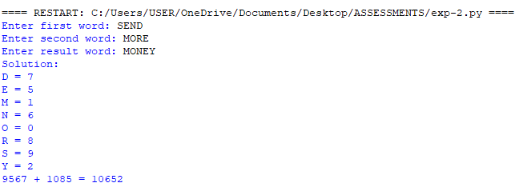

RESULT:
Thus, the Python program to solve the Crypt-Arithmetic problem was implemented successfully, and the correct digit assignment satisfying the given arithmetic equation was obtained.

